Mortgage
Posted September 07 2016
by PenFed Team
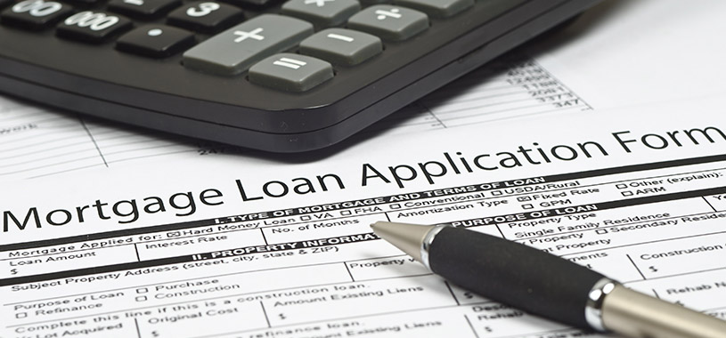

IMPORTANT DOCUMENTS YOU'LL NEED
You’ve done your research and identified how much can you afford to spend on a home with our affordability calculator. You’ve got an idea of the kind of loan you’d like to use. Now it’s time to gather your documents and get ready to apply.
You’ll need:

PROOF OF INCOME
- List of your employers for the past two years
- Pay stubs for the past two to three months
- W-2 statements
- Tax returns for the past two years
- Self-employed individuals will need to provide additional documentation, prepared and signed by an accountant

PROOF OF ASSETS
- Bank account statements from the past three months
- Security accounts (stocks, bonds, life insurance)
- List of all property owned

A COMPLETE ACCOUNTING OF DEBTS
- Statements for existing loans, including car loans, student loans and lines of credit
- Your current mortgage statement
- Credit card accounts
- 401(k) accounts

PROOF OF INSURANCE
- Homeowner’s insurance
- Title insurance

PERSONAL INFO & BACKGROUND
- Social Security number
- Prior three years residential addresses including dates
- State identification card or your state driver’s license

DOCUMENTS FOR SPECIAL CIRCUMSTANCES
- Disability or Social Security Income
- Pension Income
- Veteran’s Certificate of Eligibility

